Task 02
2.Difference between call by value and call by reference:
Call by value | Call by reference
- The original variable is not modified on changes in other variables. | - The original variable gets modified on changes in other variables.
- Actual and copied variables will be created in different memory locations. | - Actual and copied variables are created in the same memory location.
- On passing variables in a function, any changes made in the passed variable will not affect the original one. | - On passing variables in a function, any changes made in the passed parameter will update the original variable’s reference too.

3.How to copy by value a composite datatype (array+objects).
Arrays, objects, functions are all of object type which comes under composite data types. As we know variable holds data in case of composite data type it holds reference that is address of that particular value in memory.
var a= 10; // here a holds the value 10.
var b= [10,20] // b holds some address like 8023 etc.. not 10 and 20.
Therefore we can’t clone data in composite data types. To do that spread operator is used, that is three dots (…), it spreads the elements of that particular array or object and its values can be used to assign to some other variable.
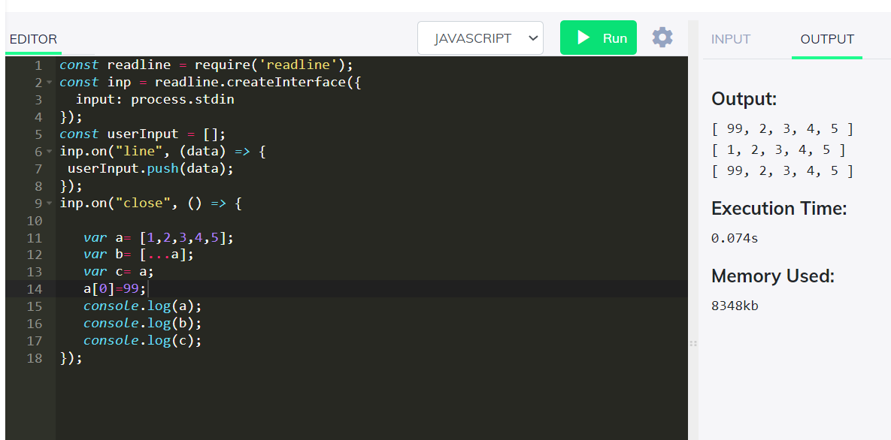
Here in line 12, I used spread operator. Therefore by changing the value in array a didn’t affect the array c. Whereas in line 13 I simply copied it that is I gave reference so, by changing a it also changes c.
{ for non-coders or beginners like me.. imagine your dad bought a bike and asked to share with your brother. So bike belongs to both of you. One day your brother took your bike and parked in highway and it got crushed by a truck, because of your brother’s fault you lost the bike. But what if you have the ability to clone it like printed it with help of creation magic, even though your brother’s bike get crushed, you will still have yours.}

